**Step 1 : Create a new folder “docker-compose” on the desktop and open Git Bash.**

**Change directory to “docker-compose” by using cd command. Create sample docker file “app.js” using vi command.**

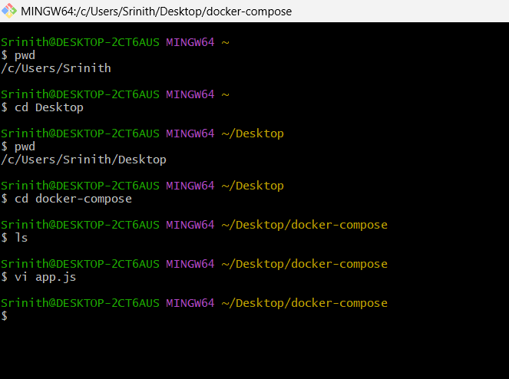

**Step 2 : app.js is opened and statement is written, save and come back to git bash using**

**:wq command.**

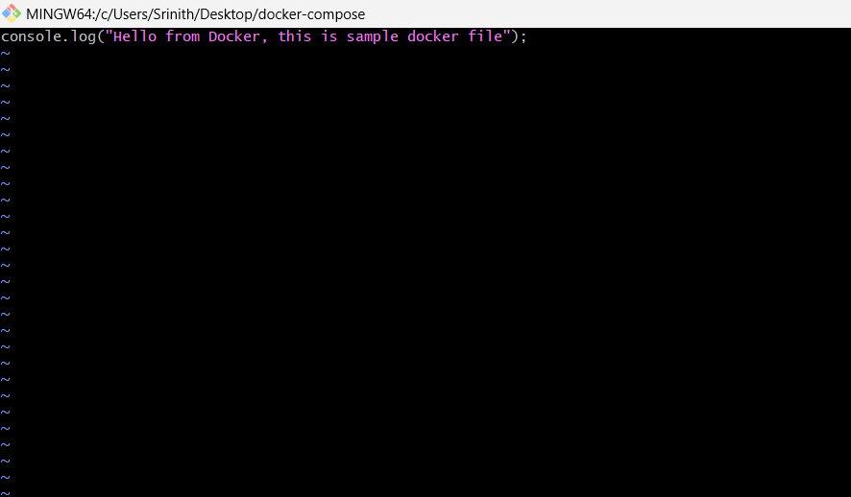

**Step 3 : Create Dockerfile using vi command.**

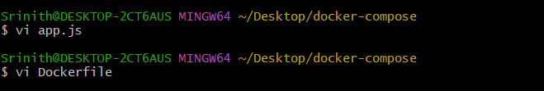

**Step 4 : Getting base image from docker by entering our credentials.**

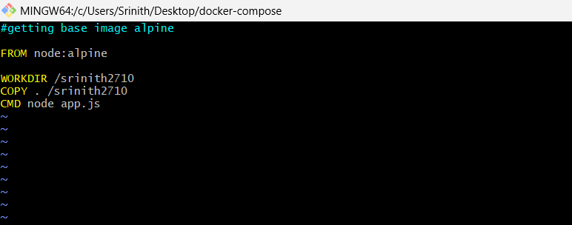

**Step 5 : Building docker image.**

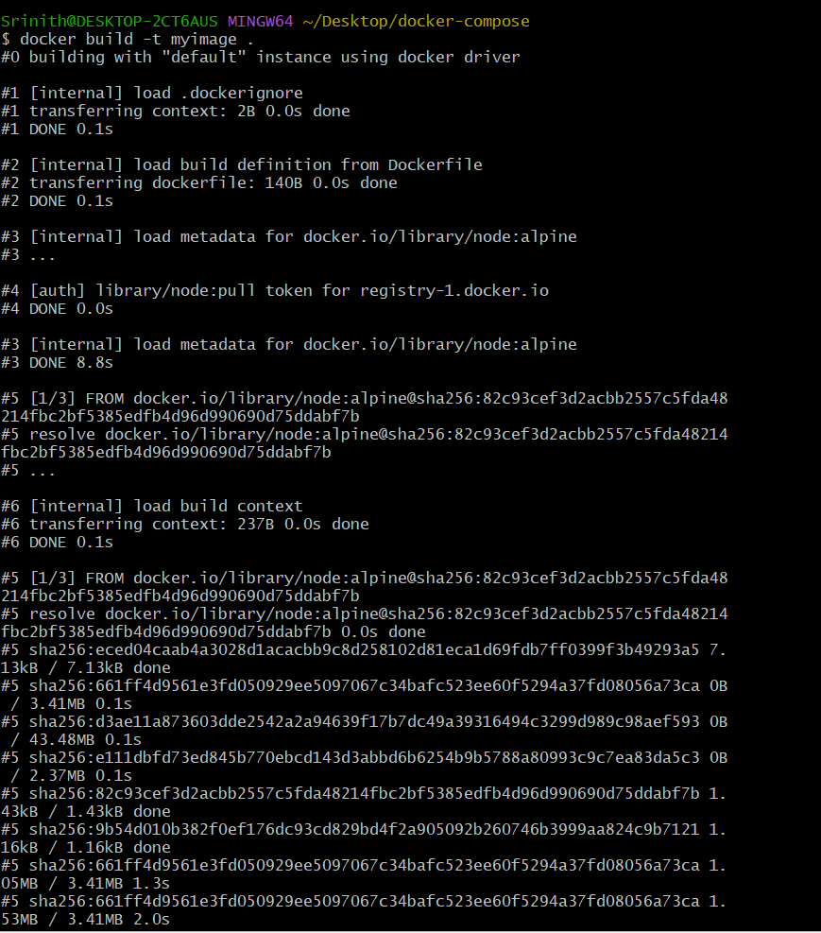

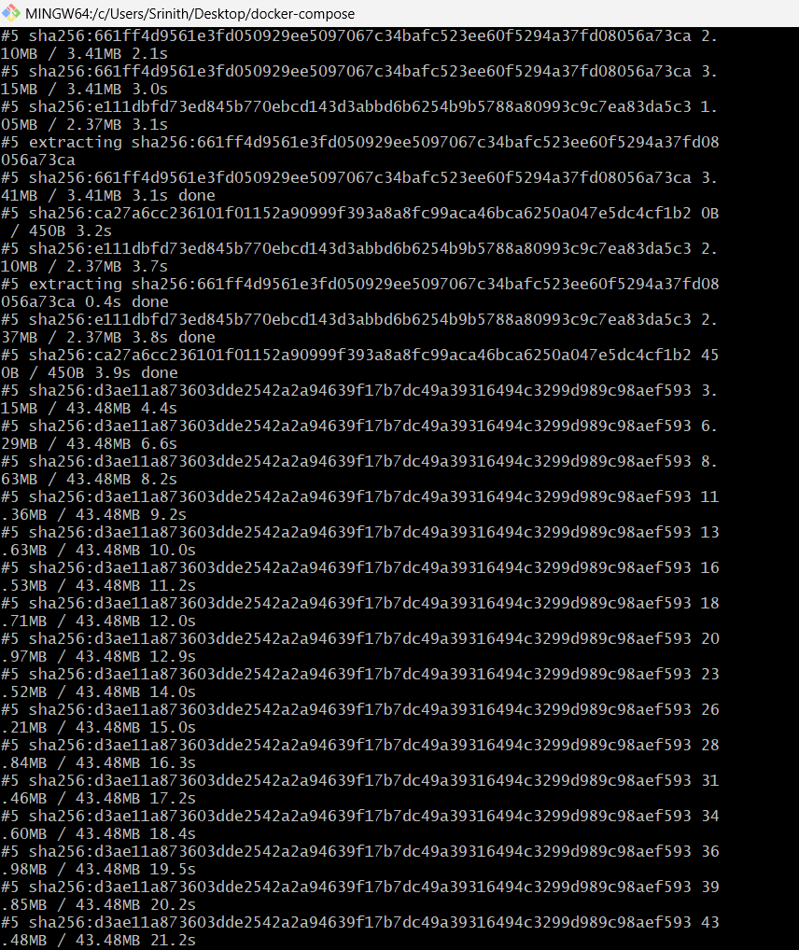

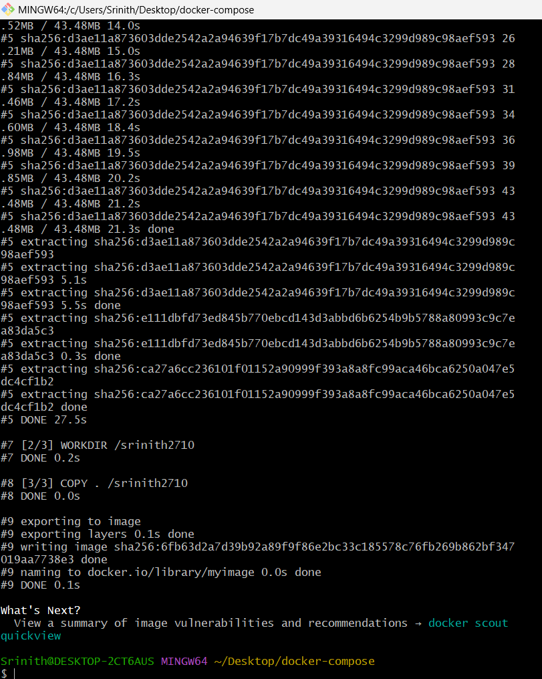

**Step 6 : List of docker images created in docker.**

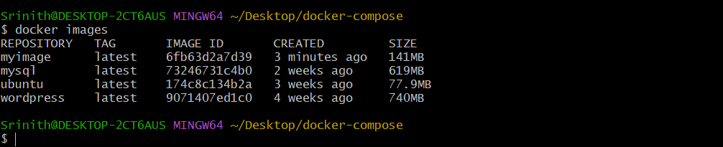

**Step 7 : Images in Docker Desktop.**

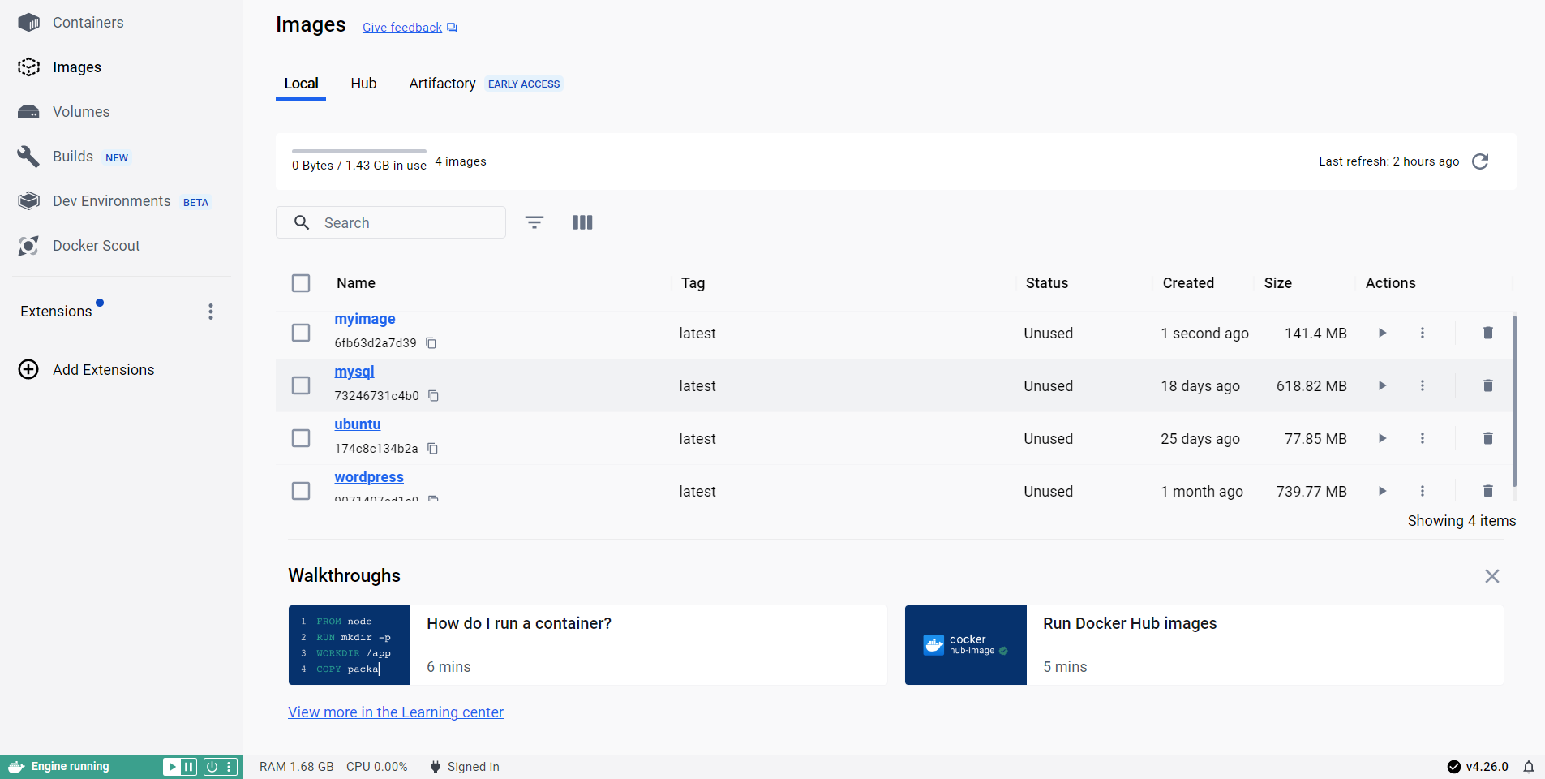

**Step 8 : By clicking on the run symbol on myimage -> Run a new container -> Select run.**

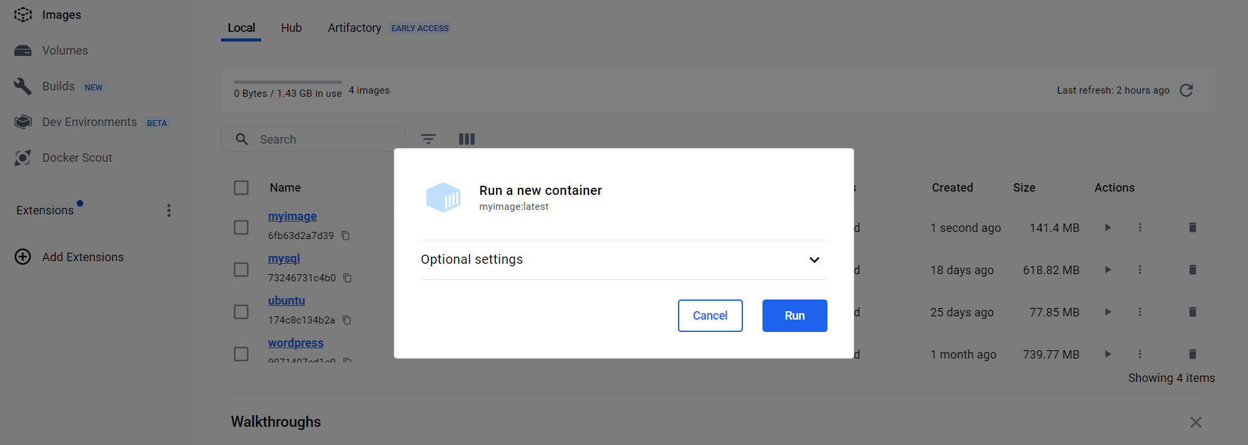

**Step 9 : Container is created.**

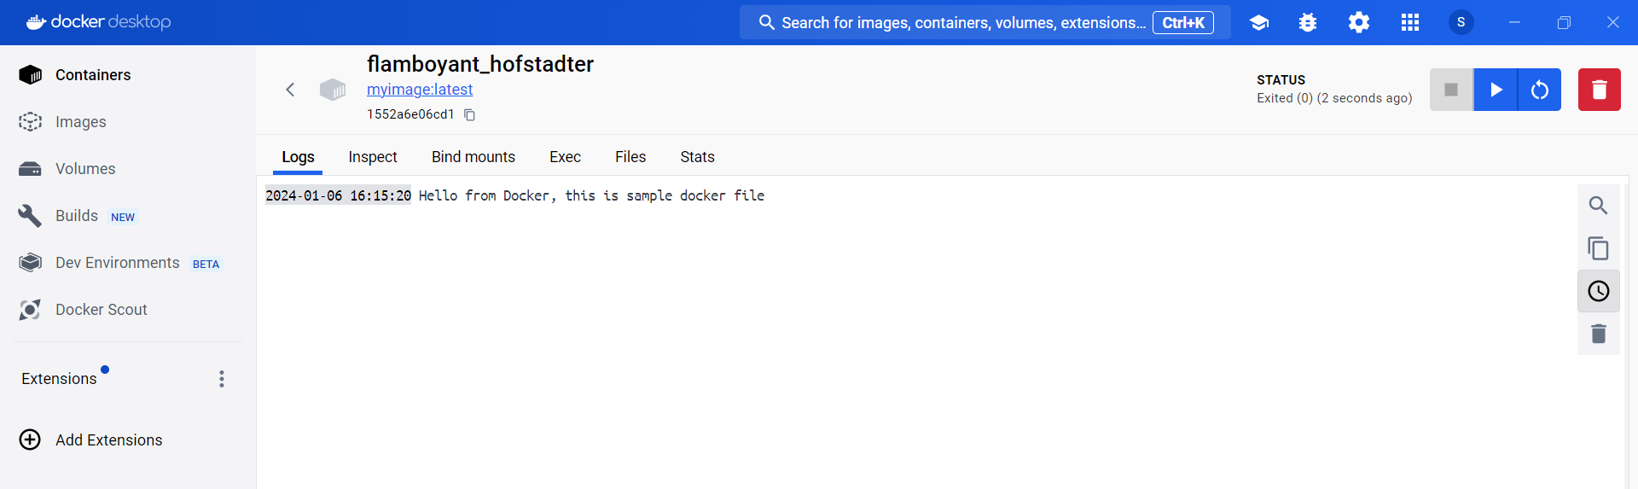

**Step 10 : List of containers in docker desktop.**

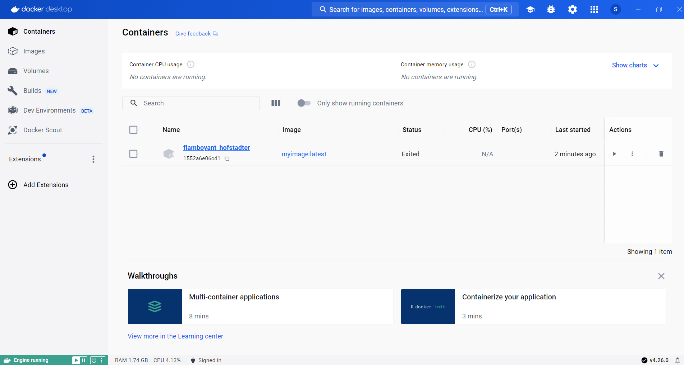

**Step 11 : Open Windows Powershell, display list of images.**

**Tag the image to target image and push to docker.**

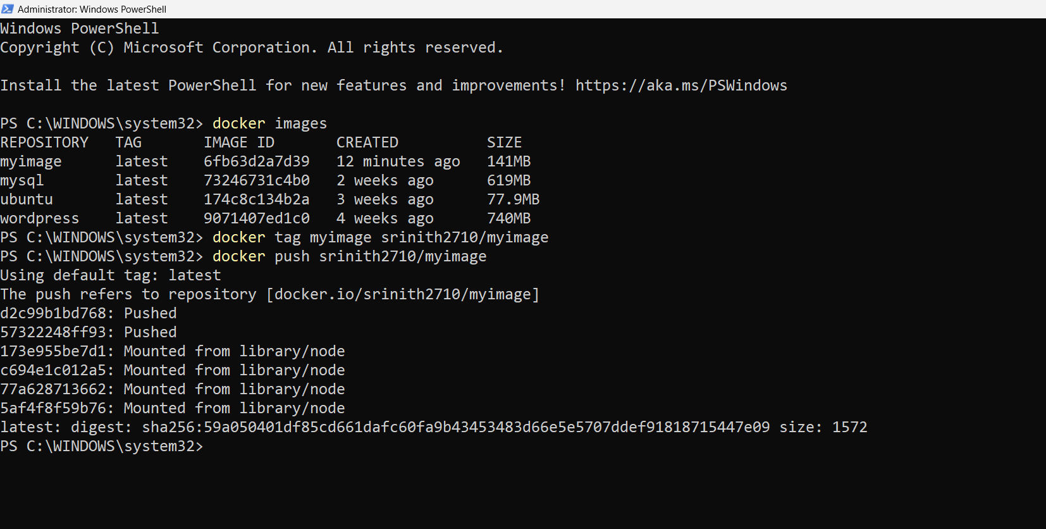

**Step 12 : New tagged image is updated in Docker desktop.**

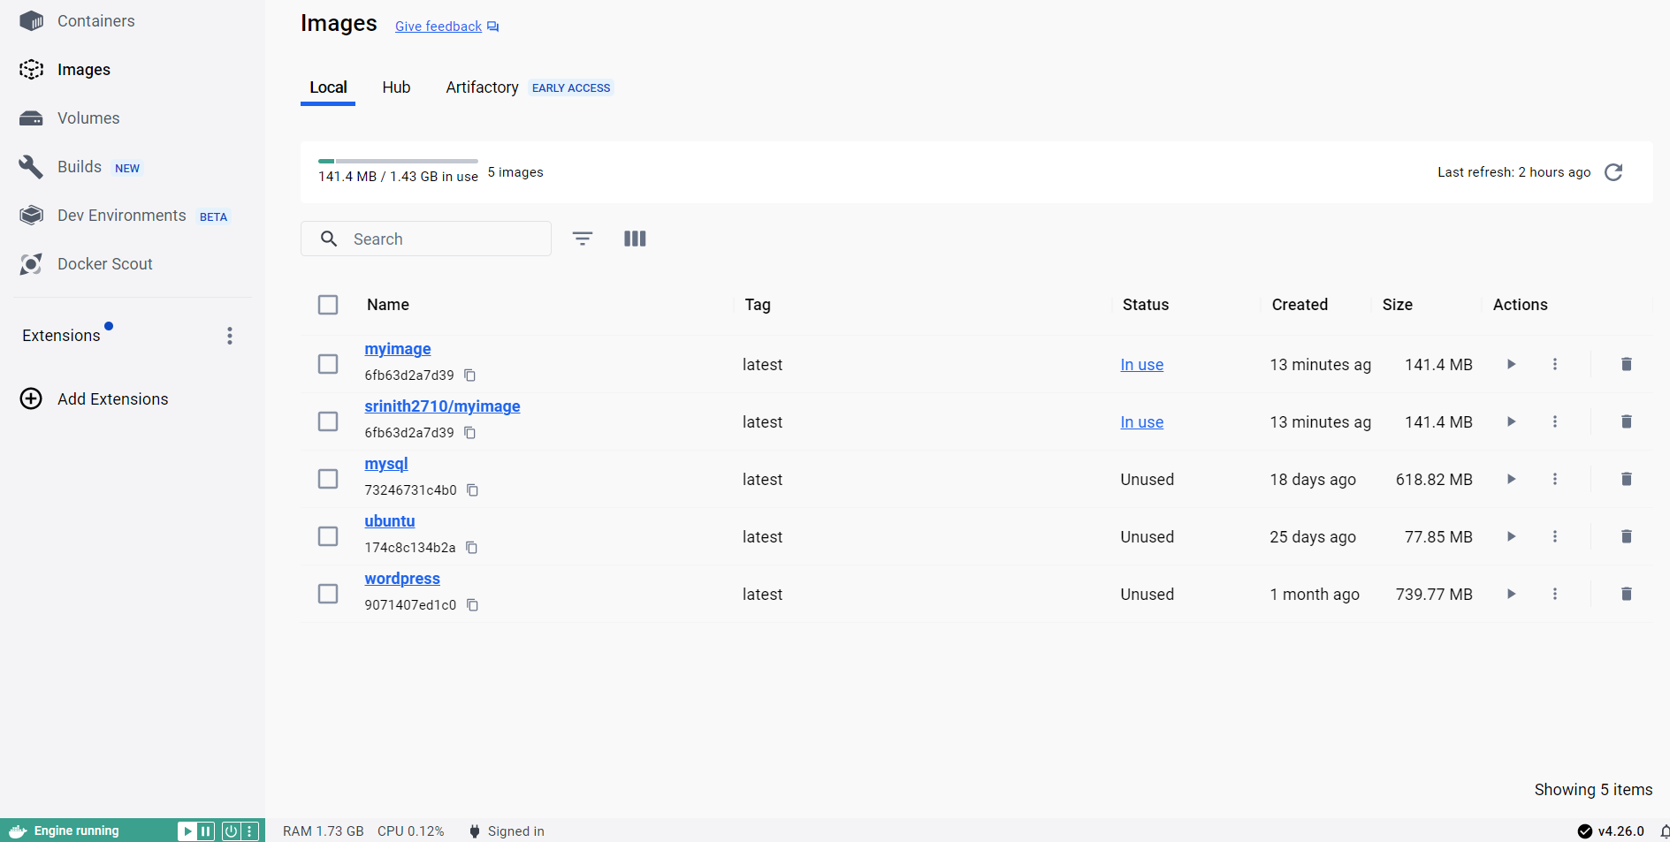

**Step 13 : The tagged image can be seen in docker hub in the browser by logging in.**

